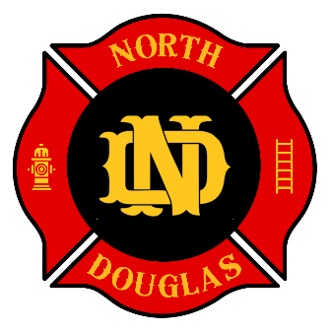 | 531 S. Cedar St./P.O. Box 277  Drain, Oregon 97435  Phone 541-836-2282  Fax 541-836-2292  NDCFEMS.US

APPLICATION FOR EMPLOYMENT – TRAINING OFFICER
This application must be completed in full and submitted with your cover letter, résumé, and certifications by the closing date.

Applicant Information

Full Name: ___________________________________________
Mailing Address: ______________________________________
City: ____________________ State: ______ ZIP: ___________
Phone: ___________________ Email: ______________________
Driver’s License #: ___________________ State: ___________ Exp: ___________
Are you a U.S. citizen or authorized to work in the U.S.? ☐ Yes ☐ No
Have you ever been employed by NDCFEMS? ☐ Yes ☐ No If yes, when? __________________
Are you claiming Veterans Preference? ☐ Yes ☐ No (attach documentation)

Certifications and Training
DPSST Firefighter II: ☐ Yes ☐ No Year: _______
DPSST Fire Instructor I: ☐ Yes ☐ No Year: _______
DPSST Fire Officer I: ☐ Yes ☐ No Year: _______
HazMat Operations: ☐ Yes ☐ No Year: _______
NWCG Firefighter Type 2: ☐ Yes ☐ No Year: _______
ICS 100 ☐ 200 ☐ 300 ☐ 700 ☐ 800 ☐ (check all completed)
EMS Level (if applicable): _______________________________

Education
High School: ______________________ Graduated? ☐ Yes ☐ No
College/University: __________________ Degree: __________________ Year: ______
Other Training or Coursework: _______________________________________________

Employment History (most recent first)

Employer #1: ___________________________________________
Position Held: ___________________ Dates Employed: __________ to __________
Supervisor: ______________________ Phone: ____________________
Reason for Leaving: ________________________________________

Employer #2: ___________________________________________
Position Held: ___________________ Dates Employed: __________ to __________
Supervisor: ______________________ Phone: ____________________
Reason for Leaving: ________________________________________

Employer #3: ___________________________________________
Position Held: ___________________ Dates Employed: __________ to __________
Supervisor: ______________________ Phone: ____________________
Reason for Leaving: ________________________________________

References (three professional references required)

Name #1: _____________________________________ Relationship: ______________
Phone: ___________________ Email: ____________________________

Name #2: _____________________________________ Relationship: ______________
Phone: ___________________ Email: ____________________________

Name #3: _____________________________________ Relationship: ______________
Phone: ___________________ Email: ____________________________

Equal Opportunity and Veterans Preference
North Douglas County Fire & EMS is an Equal Opportunity Employer. Qualified veterans and qualified regional volunteers may receive preference in accordance with applicable law and District policy. To claim preference, attach appropriate documentation with your application.

Applicant Certification and Signature
I certify that the information provided in this application is true and complete to the best of my knowledge. I understand that false or misleading information may result in disqualification or termination. I authorize North Douglas County Fire & EMS to verify information and contact references provided.

Signature: ______________________________________ Date: ________________

