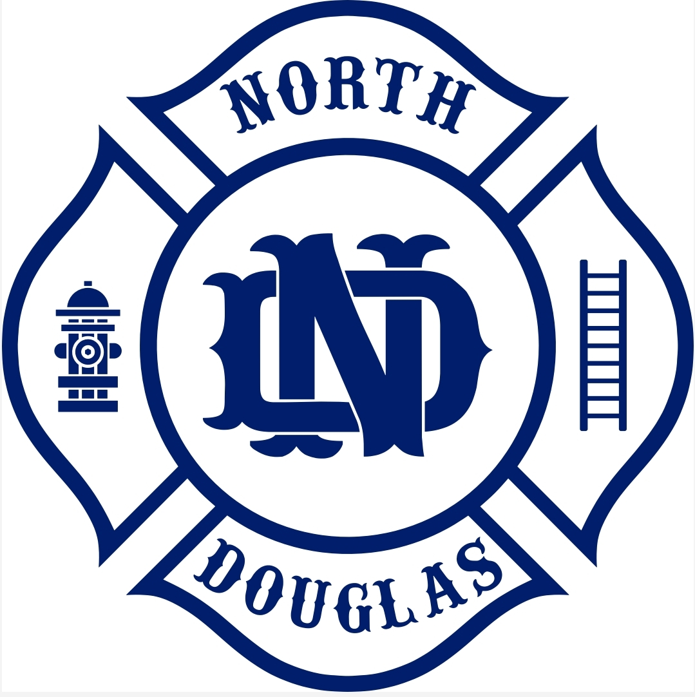

North Douglas County Fire & EMS
531 S Cedar, PO Box 277
Drain, OR 97435
Phone 541-836-2282 fax 541-836-2292

North Douglas Co. Fire & EMS
Board of Directors Meeting May 21st, 2025
531 S. Cedar St. Drain, Or 97435 6:00 PM

DUE TO THE LACK OF A QUARUM THE MEETING WAS CANCELED. A NOTICE WAS PLACED ON FACEBOOK AS SOON AS WE WERE AWARE OF IT AND NOTICES WERE PLACED ON ALL THE DOORS OF WHEN THE NEXT MEETING WOULD BE HELD.

Minutes submitted by Sheryl Barrone

